



**NAME:ANABIA SALEEM**

**ROLL NO:BSEM-F20-160**

**SECTION:5A**

**SUBJECT:MAD**

**QUESTION:01**

**(A)**

<?xml version="1.0" encoding="utf-8"?>

<androidx.constraintlayout.widget.ConstraintLayout xmlns:android="http://schemas.android.com/apk/res/android"

xmlns:app="http://schemas.android.com/apk/res-auto"

xmlns:tools="http://schemas.android.com/tools"

android:layout_width="match_parent"

android:layout_height="match_parent"

tools:context=".MainActivity">

<TextView

android:id="@+id/textView"

android:layout_width="wrap_content"

android:layout_height="wrap_content"

android:text="FAMCH"

android:textColor="@color/black"

android:textSize="50sp"

android:textStyle="bold"

app:layout_constraintBottom_toBottomOf="parent"

app:layout_constraintEnd_toEndOf="parent"

app:layout_constraintStart_toStartOf="parent"

app:layout_constraintTop_toTopOf="parent"

app:layout_constraintVertical_bias="0.382" />

<TextView

android:id="@+id/text2"

android:layout_width="wrap_content"

android:layout_height="wrap_content"

android:text="Learn .share. progress"

android:textColor="@color/black"

android:textSize="20sp"

android:textStyle="bold"

app:layout_constraintBottom_toBottomOf="parent"

app:layout_constraintEnd_toEndOf="parent"

app:layout_constraintHorizontal_bias="0.483"

app:layout_constraintStart_toStartOf="parent"

app:layout_constraintTop_toTopOf="parent"

app:layout_constraintVertical_bias="0.46" />

<TextView

android:id="@+id/s1"

android:layout_width="102dp"

android:layout_height="98dp"

android:background="@drawable/shapes"

app:layout_constraintBottom_toBottomOf="parent"

app:layout_constraintEnd_toEndOf="parent"

app:layout_constraintHorizontal_bias="0.0"

app:layout_constraintStart_toStartOf="parent"

app:layout_constraintTop_toTopOf="parent"

app:layout_constraintVertical_bias="0.685" />

<TextView

android:id="@+id/s2"

android:layout_width="185dp"

android:layout_height="175dp"

android:layout_marginStart="312dp"

android:layout_marginLeft="312dp"

android:background="@drawable/orangeshape"

android:textSize="65dp"

app:layout_constraintBottom_toBottomOf="parent"

app:layout_constraintStart_toStartOf="parent"

app:layout_constraintTop_toTopOf="parent"

app:layout_constraintVertical_bias="0.17" />

<TextView

android:id="@+id/s3"

android:layout_width="52dp"

android:layout_height="56dp"

android:background="@drawable/blueshape"

android:textSize="20dp"

app:layout_constraintBottom_toBottomOf="parent"

app:layout_constraintEnd_toEndOf="parent"

app:layout_constraintHorizontal_bias="0.955"

app:layout_constraintStart_toStartOf="parent"

app:layout_constraintTop_toTopOf="parent"

app:layout_constraintVertical_bias="0.767" />

</androidx.constraintlayout.widget.ConstraintLayout>

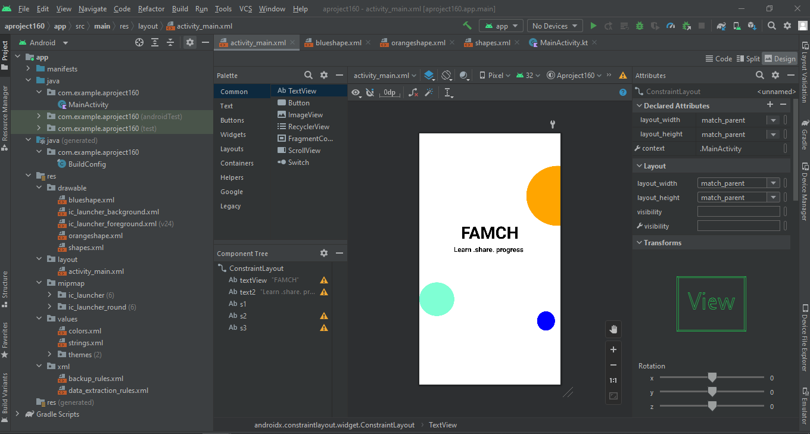

**(B)**

<?xml version="1.0" encoding="utf-8"?>

<android.support.constraint.ConstraintLayout xmlns:android="http://schemas.android.com/apk/res/android"

xmlns:app="http://schemas.android.com/apk/res-auto"

xmlns:tools="http://schemas.android.com/tools"

android:layout_width="match_parent"

android:layout_height="match_parent"

tools:context=".MainActivity">

<TextView

android:id="@+id/textView"

android:layout_width="match_parent"

android:layout_height="match_parent"

android:background="#3D3C3A"

app:layout_constraintBottom_toBottomOf="parent"

app:layout_constraintStart_toStartOf="parent"

app:layout_constraintTop_toTopOf="parent"

app:layout_constraintVertical_bias="0.0" />

<TextView

android:id="@+id/s1"

android:layout_width="350dp"

android:layout_height="50dp"

android:layout_marginStart="16dp"

android:layout_marginLeft="16dp"

android:background="@drawable/shape5"

android:textSize="20dp"

app:layout_constraintBottom_toBottomOf="parent"

app:layout_constraintStart_toStartOf="parent"

app:layout_constraintTop_toTopOf="parent"

app:layout_constraintVertical_bias="0.578" />

<TextView

android:id="@+id/s2"

android:layout_width="44dp"

android:layout_height="44dp"

android:background="@drawable/seagreen"

app:layout_constraintBottom_toBottomOf="parent"

app:layout_constraintEnd_toEndOf="parent"

app:layout_constraintHorizontal_bias="0.119"

app:layout_constraintStart_toStartOf="parent"

app:layout_constraintTop_toTopOf="parent"

app:layout_constraintVertical_bias="0.179" />

<TextView

android:layout_width="30dp"

android:layout_height="28dp"

android:background="@drawable/blueshape"

app:layout_constraintBottom_toBottomOf="parent"

app:layout_constraintEnd_toEndOf="parent"

app:layout_constraintHorizontal_bias="0.771"

app:layout_constraintStart_toStartOf="parent"

app:layout_constraintTop_toTopOf="parent"

app:layout_constraintVertical_bias="0.312" />

<TextView

android:id="@+id/t1"

android:layout_width="179dp"

android:layout_height="54dp"

android:text="FAMCH"

android:textColor="@color/white"

android:textSize="40sp"

android:textStyle="bold"

app:layout_constraintBottom_toBottomOf="parent"

app:layout_constraintEnd_toEndOf="parent"

app:layout_constraintHorizontal_bias="0.594"

app:layout_constraintStart_toStartOf="parent"

app:layout_constraintTop_toTopOf="parent"

app:layout_constraintVertical_bias="0.134" />

<TextView

android:id="@+id/textView2"

android:layout_width="wrap_content"

android:layout_height="wrap_content"

android:text="Learn .share. progress"

android:textColor="@color/white"

android:textSize="20sp"

app:layout_constraintBottom_toBottomOf="parent"

app:layout_constraintEnd_toEndOf="parent"

app:layout_constraintHorizontal_bias="0.554"

app:layout_constraintStart_toStartOf="parent"

app:layout_constraintTop_toTopOf="parent"

app:layout_constraintVertical_bias="0.223" />

<TextView

android:id="@+id/w1"

android:layout_width="414dp"

android:layout_height="462dp"

android:background="@drawable/shape4"

android:textSize="50dp"

app:layout_constraintBottom_toBottomOf="@+id/textView"

app:layout_constraintEnd_toEndOf="@+id/textView"

app:layout_constraintHorizontal_bias="1.0"

app:layout_constraintStart_toStartOf="parent"

app:layout_constraintTop_toTopOf="parent"

app:layout_constraintVertical_bias="1.0" />

<TextView

android:id="@+id/textView3"

android:layout_width="wrap_content"

android:layout_height="wrap_content"

android:text="Sign up"

android:textAlignment="center"

android:textColor="@color/black"

android:textSize="30sp"

android:textStyle="bold"

app:layout_constraintBottom_toBottomOf="parent"

app:layout_constraintEnd_toEndOf="parent"

app:layout_constraintHorizontal_bias="0.498"

app:layout_constraintStart_toStartOf="parent"

app:layout_constraintTop_toTopOf="parent"

app:layout_constraintVertical_bias="0.438" />

<EditText

android:id="@+id/textView4"

android:layout_width="350"

android:layout_height="wrap_content"

android:paddingLeft="40"

android:background="@drawable/shape5"

android:text=" Name"

android:textSize="25sp"

app:layout_constraintBottom_toBottomOf="parent"

app:layout_constraintEnd_toEndOf="parent"

app:layout_constraintHorizontal_bias="0.0"

app:layout_constraintStart_toStartOf="parent"

app:layout_constraintTop_toTopOf="parent"

app:layout_constraintVertical_bias="0.588" />

<EditText

android:id="@+id/textView3"

android:layout_width="350dp"

android:layout_height="wrap_content"

android:paddingLeft="40"

android:text="Password"

android:background="@drawable/shape5"

android:textSize="25sp"

android:textStyle="bold"

app:layout_constraintBottom_toBottomOf="parent"

app:layout_constraintEnd_toEndOf="parent"

app:layout_constraintHorizontal_bias="0.096"

app:layout_constraintStart_toStartOf="parent"

app:layout_constraintTop_toTopOf="parent"

app:layout_constraintVertical_bias="0.75" />

<EditText

android:id="@+id/textView3"

android:layout_width="350dp"

android:layout_height="wrap_content"

android:text="E-mail"

android:paddingLeft="40"

android:background="@drawable/shape6"

android:textSize="25sp"

app:layout_constraintBottom_toBottomOf="parent"

app:layout_constraintEnd_toEndOf="parent"

app:layout_constraintHorizontal_bias="0.09"

app:layout_constraintStart_toStartOf="parent"

app:layout_constraintTop_toTopOf="parent"

app:layout_constraintVertical_bias="0.667" />

<TextView

android:id="@+id/s1"

android:layout_width="41dp"

android:layout_height="37dp"

android:background="@drawable/shape1"

app:layout_constraintBottom_toBottomOf="parent"

app:layout_constraintEnd_toEndOf="parent"

app:layout_constraintHorizontal_bias="0.121"

app:layout_constraintStart_toStartOf="parent"

app:layout_constraintTop_toTopOf="parent"

app:layout_constraintVertical_bias="0.18" />

<TextView

android:id="@+id/s2"

android:layout_width="148dp"

android:layout_height="148dp"

android:layout_marginStart="336dp"

android:layout_marginLeft="336dp"

android:background="@drawable/shape2"

android:textSize="65dp"

app:layout_constraintBottom_toBottomOf="parent"

app:layout_constraintStart_toStartOf="parent"

app:layout_constraintTop_toTopOf="parent"

app:layout_constraintVertical_bias="0.117" />

<TextView

android:id="@+id/s3"

android:layout_width="25dp"

android:layout_height="27dp"

" android:background="@drawable/shape3

android:textSize="20dp"

app:layout_constraintBottom_toBottomOf="parent"

app:layout_constraintEnd_toEndOf="parent"

app:layout_constraintHorizontal_bias="0.764"

app:layout_constraintStart_toStartOf="parent"

app:layout_constraintTop_toTopOf="parent"

app:layout_constraintVertical_bias="0.313" />

<Button

<Button

android:layout_width="wrap_content"

android:layout_height="wrap_content"

android:background="#3D3C3A"

android:text="login"

android:textColor="@color/white"

android:textSize="25sp"

android:textStyle="bold"

tools:layout_editor_absoluteX="176dp"

tools:layout_editor_absoluteY="600dp" />

... />

<ImageView

android:layout_width="450dp"

android:layout_height="50dp"

android:background="@drawable/br"

tools:layout_editor_absoluteX="-20dp"

tools:layout_editor_absoluteY="681dp" />

</android.support.constraint.ConstraintLayout>

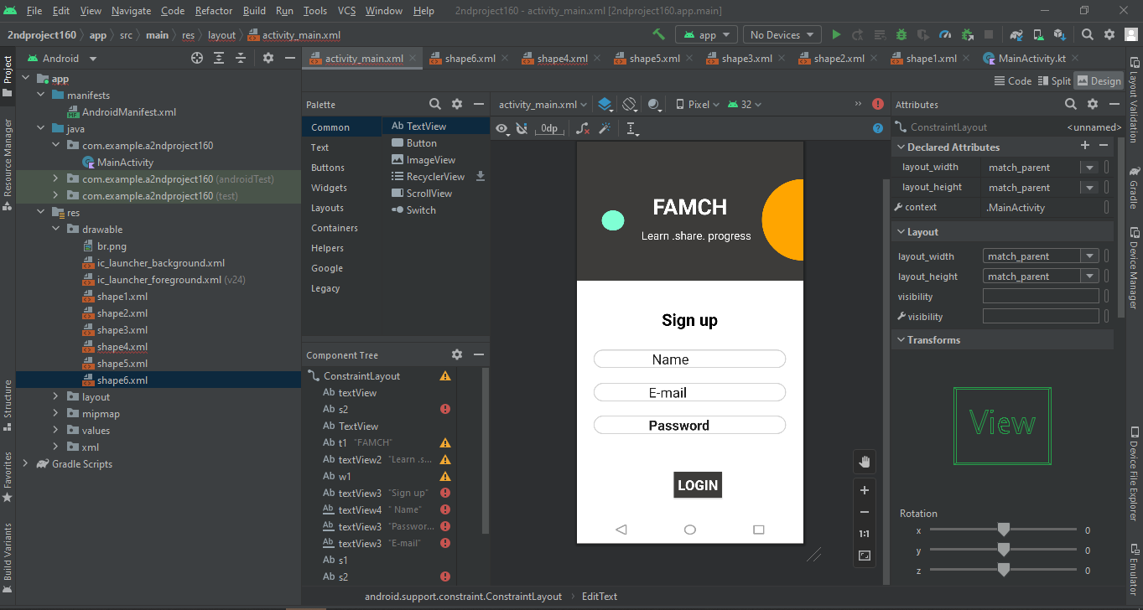

**QUESTION:2**

**(A)**

<?xml version="1.0" encoding="utf-8"?>

<androidx.constraintlayout.widget.ConstraintLayout xmlns:android="http://schemas.android.com/apk/res/android"

xmlns:app="http://schemas.android.com/apk/res-auto"

xmlns:tools="http://schemas.android.com/tools"

android:layout_width="match_parent"

android:layout_height="match_parent"

tools:context=".MainActivity">

<ImageView

android:layout_width="200dp"

android:layout_height="200dp"

android:background="@drawable/tree"

tools:layout_editor_absoluteX="114dp"

tools:layout_editor_absoluteY="16dp" />

<TextView

android:id="@+id/s1"

android:layout_width="400dp"

android:layout_height="470dp"

android:layout_marginStart="4dp"

android:layout_marginLeft="4dp"

android:background="@drawable/shape"

android:textSize="20dp"

app:layout_constraintBottom_toBottomOf="parent"

app:layout_constraintStart_toStartOf="parent"

app:layout_constraintTop_toTopOf="parent"

app:layout_constraintVertical_bias="0.938" />

<ImageView

android:layout_width="50dp"

android:layout_height="50dp"

android:background="@drawable/ic_baseline_supervised_user_circle_24"

tools:layout_editor_absoluteX="16dp"

tools:layout_editor_absoluteY="327dp" />

<ImageView

android:layout_width="50dp"

android:layout_height="50dp"

android:background="@drawable/ic_baseline_lock_24"

tools:layout_editor_absoluteX="16dp"

tools:layout_editor_absoluteY="387dp" />

<Button

android:id="@+id/textView3"

android:layout_width="wrap_content"

android:layout_height="wrap_content"

android:background="@color/white"

android:text="Sign In"

android:textAlignment="center"

android:textColor="#000000"

android:textSize="30sp"

android:textStyle="normal"

app:backgroundTint="#FFFFFF"

app:layout_constraintBottom_toBottomOf="parent"

app:layout_constraintEnd_toEndOf="parent"

app:layout_constraintStart_toStartOf="parent"

app:layout_constraintTop_toTopOf="parent"

app:layout_constraintVertical_bias="0.818" />

<EditText

android:id="@+id/textView3"

android:layout_width="match_parent"

android:layout_height="wrap_content"

android:paddingLeft="40"

android:text=" Password"

android:textColor="@color/white"

android:textSize="35sp"

app:layout_constraintBottom_toBottomOf="parent"

app:layout_constraintEnd_toEndOf="parent"

app:layout_constraintHorizontal_bias="1.0"

app:layout_constraintStart_toStartOf="parent"

app:layout_constraintTop_toTopOf="parent"

app:layout_constraintVertical_bias="0.583" />

<TextView

android:id="@+id/textView"

android:layout_width="wrap_content"

android:layout_height="wrap_content"

android:text="Forget Password"

android:textSize="20dp"

android:textColor="@color/white"

app:autoSizeTextType="uniform"

tools:layout_editor_absoluteX="243dp"

tools:layout_editor_absoluteY="471dp" />

<TextView

android:id="@+id/textView2"

android:layout_width="wrap_content"

android:layout_height="wrap_content"

android:text="Now User? Sign Up"

android:textColor="@color/white"

android:textSize="20dp"

tools:layout_editor_absoluteX="123dp"

tools:layout_editor_absoluteY="621dp" />

<EditText

android:id="@+id/editTextTextPersonName"

android:layout_width="wrap_content"

android:layout_height="wrap_content"

android:ems="20"

android:inputType="textPersonName"

android:text=" UserName"

android:textColor="@color/white"

android:textSize="35sp"

tools:layout_editor_absoluteX="41dp"

tools:layout_editor_absoluteY="319dp" />

</androidx.constraintlayout.widget.ConstraintLayout>

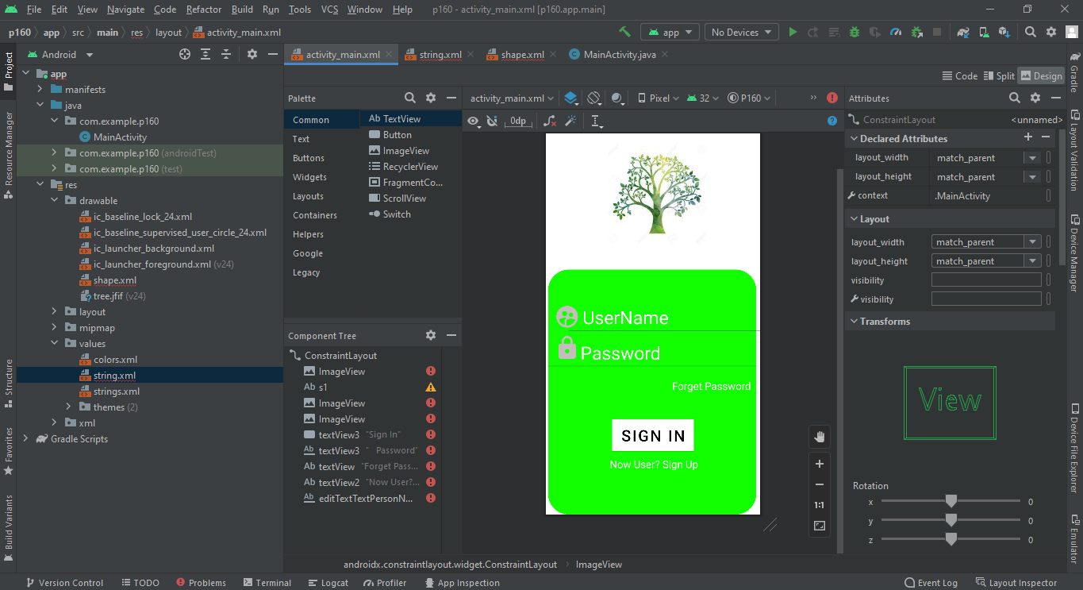

**(B)**

<?xml version="1.0" encoding="utf-8"?>

<androidx.constraintlayout.widget.ConstraintLayout xmlns:android="http://schemas.android.com/apk/res/android"

xmlns:app="http://schemas.android.com/apk/res-auto"

xmlns:tools="http://schemas.android.com/tools"

android:layout_width="match_parent"

android:layout_height="match_parent"

tools:context=".MainActivity">

<ImageView

android:id="@+id/imageView2"

android:layout_width="34dp"

android:layout_height="36dp"

android:background="@drawable/ic_baseline_search_24"

tools:layout_editor_absoluteX="31dp"

tools:layout_editor_absoluteY="200dp" />

<ImageView

android:id="@+id/imageView2"

android:layout_width="50dp"

android:layout_height="50dp"

android:background="@drawable/ic_baseline_menu_24"

tools:layout_editor_absoluteX="12dp"

tools:layout_editor_absoluteY="16dp" />

<ImageView

android:id="@+id/imageView2"

android:layout_width="50dp"

android:layout_height="50dp"

android:background="@drawable/ic_baseline_shopping_cart_24"

tools:layout_editor_absoluteX="345dp"

tools:layout_editor_absoluteY="16dp" />

<ImageView

android:id="@+id/imageView2"

android:layout_width="200dp"

android:layout_height="200dp"

android:background="@drawable/PLANT11"

tools:layout_editor_absoluteX="12dp"

tools:layout_editor_absoluteY="313dp" />

<ImageView

android:id="@+id/imageView"

android:layout_width="200dp"

android:layout_height="200dp"

android:layout_marginStart="12dp"

android:background="@drawable/plant4"

app:layout_constraintStart_toEndOf="@+id/imageView3"

tools:layout_editor_absoluteY="515dp" />

<ImageView

android:id="@+id/imageView3"

android:layout_width="200dp"

android:layout_height="200dp"

android:layout_marginStart="11dp"

android:layout_marginTop="2dp"

android:layout_marginEnd="12dp"

android:layout_marginBottom="16dp"

android:background="@drawable/plant3"

app:layout_constraintBottom_toBottomOf="parent"

app:layout_constraintEnd_toStartOf="@+id/imageView"

app:layout_constraintStart_toStartOf="parent"

app:layout_constraintTop_toBottomOf="@+id/imageView2" />

<ImageView

android:layout_width="200dp"

android:layout_height="200dp"

android:background="@drawable/plant22"

tools:layout_editor_absoluteX="212dp"

tools:layout_editor_absoluteY="313dp" />

<TextView

android:id="@+id/textView"

android:layout_width="wrap_content"

android:layout_height="wrap_content"

android:layout_marginEnd="278dp"

app:layout_constraintEnd_toEndOf="parent"

tools:layout_editor_absoluteY="81dp" />

<TextView

android:id="@+id/textView2"

android:layout_width="wrap_content"

android:layout_height="wrap_content"

android:text="What kind "

android:textColor="@color/black"

android:textSize="30sp"

android:textStyle="bold"

tools:layout_editor_absoluteX="13dp"

tools:layout_editor_absoluteY="100dp" />

<TextView

android:id="@+id/textView2"

android:layout_width="350dp"

android:layout_height="wrap_content"

android:text=" Search "

android:textSize="30sp"

tools:layout_editor_absoluteX="30dp"

tools:layout_editor_absoluteY="196dp" />

<TextView

android:id="@+id/textView3"

android:layout_width="wrap_content"

android:layout_height="wrap_content"

android:text="of Plant You Want"

android:textColor="@color/black"

android:textSize="30sp"

android:textStyle="bold"

tools:layout_editor_absoluteX="11dp"

tools:layout_editor_absoluteY="140dp" />

<TextView

android:id="@+id/textView4"

android:layout_width="wrap_content"

android:layout_height="wrap_content"

android:text="All"

android:textColor="@color/black"

android:textSize="20sp"

tools:layout_editor_absoluteX="31dp"

tools:layout_editor_absoluteY="281dp" />

<TextView

android:id="@+id/textView5"

android:layout_width="wrap_content"

android:layout_height="wrap_content"

android:text="Small"

android:textColor="@color/black"

android:textSize="20sp"

tools:layout_editor_absoluteX="105dp"

tools:layout_editor_absoluteY="281dp" />

<TextView

android:id="@+id/textView6"

android:layout_width="wrap_content"

android:layout_height="wrap_content"

android:text="Medium"

android:textColor="@color/black"

android:textSize="20sp"

tools:layout_editor_absoluteX="200dp"

tools:layout_editor_absoluteY="281dp" />

<TextView

android:id="@+id/textView7"

android:layout_width="wrap_content"

android:layout_height="wrap_content"

android:text="Hanging"

android:textColor="@color/black"

android:textSize="20sp"

tools:layout_editor_absoluteX="307dp"

tools:layout_editor_absoluteY="281dp" />

</androidx.constraintlayout.widget.ConstraintLayout>

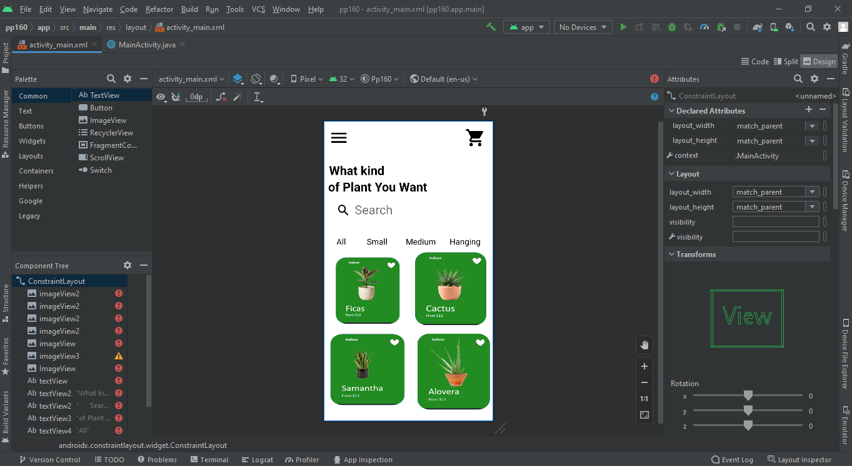

**(C)**

<?xml version="1.0" encoding="utf-8"?>

<androidx.constraintlayout.widget.ConstraintLayout xmlns:android="http://schemas.android.com/apk/res/android"

xmlns:app="http://schemas.android.com/apk/res-auto"

xmlns:tools="http://schemas.android.com/tools"

android:layout_width="match_parent"

android:layout_height="match_parent"

tools:context=".MainActivity">

<ImageView

android:id="@+id/imageView2"

android:layout_width="50dp"

android:layout_height="50dp"

android:background="@drawable/left"

tools:layout_editor_absoluteX="19dp"

tools:layout_editor_absoluteY="16dp" />

<ImageView

android:id="@+id/imageView2"

android:layout_width="50dp"

android:layout_height="50dp"

android:background="@drawable/heart"

tools:layout_editor_absoluteX="345dp"

tools:layout_editor_absoluteY="16dp" />

<ImageView

android:id="@+id/imageView2"

android:layout_width="300dp"

android:layout_height="300dp"

android:background="@drawable/tree"

tools:layout_editor_absoluteX="55dp"

tools:layout_editor_absoluteY="84dp" />

<TextView

android:id="@+id/textView"

android:layout_width="wrap_content"

android:layout_height="wrap_content"

android:text="Samantha Tree"

android:textColor="@color/black"

android:textSize="30sp"

android:textStyle="bold"

tools:layout_editor_absoluteX="16dp"

tools:layout_editor_absoluteY="445dp" />

<ImageView

android:id="@+id/imageView2"

android:layout_width="120dp"

android:layout_height="120dp"

android:background="@drawable/star"

tools:layout_editor_absoluteX="275dp"

tools:layout_editor_absoluteY="485dp" />

<ImageView

android:id="@+id/imageView2"

android:layout_width="30dp"

android:layout_height="30dp"

android:background="@drawable/p"

tools:layout_editor_absoluteX="25dp"

tools:layout_editor_absoluteY="531dp" />

<ImageView

android:id="@+id/imageView2"

android:layout_width="30dp"

android:layout_height="30dp"

android:background="@drawable/n"

tools:layout_editor_absoluteX="69dp"

tools:layout_editor_absoluteY="531dp" />

<TextView

android:id="@+id/textView2"

android:layout_width="wrap_content"

android:layout_height="wrap_content"

android:text="Regular Price $195.00"

android:textColor="@color/black"

android:textSize="20sp"

tools:layout_editor_absoluteX="16dp"

tools:layout_editor_absoluteY="485dp" />

<TextView

android:id="@+id/textView3"

android:layout_width="wrap_content"

android:layout_height="wrap_content"

android:text="1"

android:textColor="@color/black"

android:textSize="25sp"

tools:layout_editor_absoluteX="55dp"

tools:layout_editor_absoluteY="527dp" />

<Button

android:id="@+id/button"

android:layout_width="wrap_content"

android:layout_height="wrap_content"

android:text="Buy Now"

app:backgroundTint="#065909"

tools:layout_editor_absoluteX="154dp"

tools:layout_editor_absoluteY="643dp" />

<TextView

android:id="@+id/textView4"

android:layout_width="wrap_content"

android:layout_height="wrap_content"

android:text="It is a long established fact that a reader will be distracted by the readable content of a page when looking at its layout."

android:textSize="15sp"

tools:layout_editor_absoluteX="0dp"

tools:layout_editor_absoluteY="580dp" />

</androidx.constraintlayout.widget.ConstraintLayout>

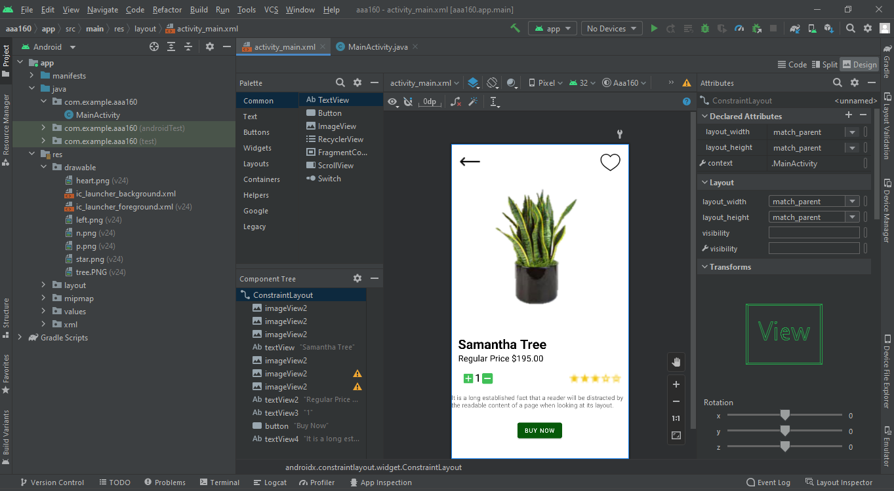

**QUESTION:3**

**CONSTRAINT LAYOUT**

<?xml version="1.0" encoding="utf-8"?>

<androidx.constraintlayout.widget.ConstraintLayout xmlns:android="http://schemas.android.com/apk/res/android"

xmlns:app="http://schemas.android.com/apk/res-auto"

xmlns:tools="http://schemas.android.com/tools"

android:layout_width="match_parent"

android:layout_height="match_parent"

android:background="@drawable/background"

tools:context=".MainActivity"

>

<TextView

android:id="@+id/textView14"

android:layout_width="wrap_content"

android:layout_height="wrap_content"

android:text=" Instagram"

android:textColor="@color/white"

tools:layout_editor_absoluteX="317dp"

tools:layout_editor_absoluteY="503dp" />

<ImageView

android:layout_width="94dp"

android:layout_height="75dp"

android:background="@drawable/weather"

tools:layout_editor_absoluteX="317dp"

tools:layout_editor_absoluteY="141dp" />

<ImageView

android:layout_width="78dp"

android:layout_height="75dp"

android:background="@drawable/setting"

tools:layout_editor_absoluteX="317dp"

tools:layout_editor_absoluteY="334dp" />

<ImageView

android:layout_width="78dp"

android:layout_height="75dp"

android:background="@drawable/whatsapp"

tools:layout_editor_absoluteX="111dp"

tools:layout_editor_absoluteY="42dp" />

<ImageView

android:layout_width="78dp"

android:layout_height="75dp"

android:background="@drawable/tiktok"

tools:layout_editor_absoluteX="110dp"

tools:layout_editor_absoluteY="141dp" />

<ImageView

android:layout_width="78dp"

android:layout_height="75dp"

android:background="@drawable/snapchat"

tools:layout_editor_absoluteX="115dp"

tools:layout_editor_absoluteY="423dp" />

<ImageView

android:layout_width="78dp"

android:layout_height="75dp"

android:background="@drawable/messages"

tools:layout_editor_absoluteX="110dp"

tools:layout_editor_absoluteY="562dp" />

<ImageView

android:layout_width="78dp"

android:layout_height="75dp"

android:background="@drawable/instagram"

tools:layout_editor_absoluteX="317dp"

tools:layout_editor_absoluteY="428dp" />

<ImageView

android:layout_width="450dp"

android:layout_height="50dp"

android:background="@drawable/br"

tools:layout_editor_absoluteX="-20dp"

tools:layout_editor_absoluteY="681dp" />

<ImageView

android:layout_width="78dp"

android:layout_height="75dp"

android:background="@drawable/phone"

tools:layout_editor_absoluteX="7dp"

tools:layout_editor_absoluteY="562dp" />

<ImageView

android:layout_width="78dp"

android:layout_height="75dp"

android:background="@drawable/facebook"

tools:layout_editor_absoluteX="229dp"

tools:layout_editor_absoluteY="427dp" />

<ImageView

android:layout_width="78dp"

android:layout_height="75dp"

android:background="@drawable/clock"

tools:layout_editor_absoluteX="7dp"

tools:layout_editor_absoluteY="423dp" />

<ImageView

android:layout_width="78dp"

android:layout_height="75dp"

android:background="@drawable/camera"

tools:layout_editor_absoluteX="313dp"

tools:layout_editor_absoluteY="562dp" />

<ImageView

android:layout_width="78dp"

android:layout_height="75dp"

android:background="@drawable/twitter"

tools:layout_editor_absoluteX="229dp"

tools:layout_editor_absoluteY="333dp" />

<ImageView

android:layout_width="78dp"

android:layout_height="75dp"

android:background="@drawable/play"

tools:layout_editor_absoluteX="111dp"

tools:layout_editor_absoluteY="329dp" />

<ImageView

android:layout_width="78dp"

android:layout_height="75dp"

android:background="@drawable/gmail"

tools:layout_editor_absoluteX="7dp"

tools:layout_editor_absoluteY="329dp" />

<ImageView

android:layout_width="78dp"

android:layout_height="75dp"

android:background="@drawable/ludo"

tools:layout_editor_absoluteX="313dp"

tools:layout_editor_absoluteY="240dp" />

<ImageView

android:layout_width="78dp"

android:layout_height="75dp"

android:background="@drawable/google"

tools:layout_editor_absoluteX="228dp"

tools:layout_editor_absoluteY="239dp" />

<ImageView

android:layout_width="78dp"

android:layout_height="75dp"

android:background="@drawable/game"

tools:layout_editor_absoluteX="111dp"

tools:layout_editor_absoluteY="239dp" />

<ImageView

android:layout_width="78dp"

android:layout_height="75dp"

android:background="@drawable/folder"

tools:layout_editor_absoluteX="7dp"

tools:layout_editor_absoluteY="235dp" />

<ImageView

android:layout_width="78dp"

android:layout_height="75dp"

android:background="@drawable/drive"

tools:layout_editor_absoluteX="219dp"

tools:layout_editor_absoluteY="141dp" />

<ImageView

android:layout_width="78dp"

android:layout_height="75dp"

android:background="@drawable/contact"

tools:layout_editor_absoluteX="219dp"

tools:layout_editor_absoluteY="562dp" />

<ImageView

android:layout_width="78dp"

android:layout_height="75dp"

android:background="@drawable/calendar"

tools:layout_editor_absoluteX="7dp"

tools:layout_editor_absoluteY="141dp" />

<ImageView

android:layout_width="78dp"

android:layout_height="75dp"

android:background="@drawable/calculator"

tools:layout_editor_absoluteX="317dp"

tools:layout_editor_absoluteY="42dp" />

<ImageView

android:layout_width="78dp"

android:layout_height="75dp"

android:background="@drawable/album"

tools:layout_editor_absoluteX="221dp"

tools:layout_editor_absoluteY="42dp" />

<ImageView

android:layout_width="25dp"

android:layout_height="25dp"

android:background="@drawable/battery"

android:text="99%"

android:textColor="@color/white"

tools:layout_editor_absoluteX="391dp"

tools:layout_editor_absoluteY="-2dp" />

<ImageView

android:layout_width="78dp"

android:layout_height="75dp"

android:background="@drawable/youtube"

tools:layout_editor_absoluteX="7dp"

tools:layout_editor_absoluteY="42dp" />

<ImageView

android:layout_width="20dp"

android:layout_height="20dp"

android:background="@drawable/signal"

tools:layout_editor_absoluteX="369dp"

tools:layout_editor_absoluteY="3dp" />

<TextView

android:id="@+id/textView2"

android:layout_width="62dp"

android:layout_height="24dp"

android:layout_weight="1"

android:text="Youtube"

android:textColor="@color/white"

tools:layout_editor_absoluteX="16dp"

tools:layout_editor_absoluteY="117dp" />

<TextView

android:id="@+id/textView3"

android:layout_width="78dp"

android:layout_height="24dp"

android:layout_weight="1"

android:text="weather"

android:textColor="@color/white"

tools:layout_editor_absoluteX="330dp"

tools:layout_editor_absoluteY="216dp" />

<TextView

android:id="@+id/textView"

android:layout_width="65dp"

android:layout_height="23dp"

android:text="Tiktok"

android:textColor="@color/white"

tools:layout_editor_absoluteX="123dp"

tools:layout_editor_absoluteY="216dp" />

<TextView

android:id="@+id/textView4"

android:layout_width="wrap_content"

android:layout_height="wrap_content"

android:text="Google"

android:textColor="@color/white"

tools:layout_editor_absoluteX="246dp"

tools:layout_editor_absoluteY="314dp" />

<TextView

android:id="@+id/textView5"

android:layout_width="wrap_content"

android:layout_height="wrap_content"

android:text="Photo"

android:textColor="@color/white"

tools:layout_editor_absoluteX="241dp"

tools:layout_editor_absoluteY="122dp" />

<TextView

android:id="@+id/textView5"

android:layout_width="wrap_content"

android:layout_height="wrap_content"

android:text="12:45"

android:textColor="@color/white"

tools:layout_editor_absoluteX="16dp"

tools:layout_editor_absoluteY="4dp" />

<TextView

android:id="@+id/textView6"

android:layout_width="wrap_content"

android:layout_height="wrap_content"

android:text="Calendar"

android:textColor="@color/white"

tools:layout_editor_absoluteX="16dp"

tools:layout_editor_absoluteY="216dp" />

<TextView

android:id="@+id/textView7"

android:layout_width="wrap_content"

android:layout_height="wrap_content"

android:text="My File"

android:textColor="@color/white"

tools:layout_editor_absoluteX="27dp"

tools:layout_editor_absoluteY="310dp" />

<TextView

android:id="@+id/textView8"

android:layout_width="wrap_content"

android:layout_height="wrap_content"

android:text="Drive"

android:textColor="@color/white"

tools:layout_editor_absoluteX="246dp"

tools:layout_editor_absoluteY="216dp" />

<TextView

android:id="@+id/textView9"

android:layout_width="wrap_content"

android:layout_height="wrap_content"

android:text="Play Store"

android:textColor="@color/white"

tools:layout_editor_absoluteX="123dp"

tools:layout_editor_absoluteY="404dp" />

<TextView

android:id="@+id/textView10"

android:layout_width="wrap_content"

android:layout_height="wrap_content"

android:text="Twitter"

android:textColor="@color/white"

tools:layout_editor_absoluteX="246dp"

tools:layout_editor_absoluteY="408dp" />

<TextView

android:id="@+id/textView11"

android:layout_width="wrap_content"

android:layout_height="wrap_content"

android:text="Games"

android:textColor="@color/white"

tools:layout_editor_absoluteX="124dp"

tools:layout_editor_absoluteY="314dp" />

<TextView

android:id="@+id/textView12"

android:layout_width="wrap_content"

android:layout_height="wrap_content"

android:text="Whatsapp"

android:textColor="@color/white"

tools:layout_editor_absoluteX="115dp"

tools:layout_editor_absoluteY="122dp" />

<TextView

android:id="@+id/textView13"

android:layout_width="wrap_content"

android:layout_height="wrap_content"

android:text="Mail"

android:textColor="@color/white"

tools:layout_editor_absoluteX="35dp"

tools:layout_editor_absoluteY="404dp" />

<TextView

android:id="@+id/textView15"

android:layout_width="wrap_content"

android:layout_height="wrap_content"

android:text="Setting"

android:textColor="@color/white"

tools:layout_editor_absoluteX="330dp"

tools:layout_editor_absoluteY="409dp" />

<TextView

android:id="@+id/textView16"

android:layout_width="wrap_content"

android:layout_height="wrap_content"

android:text="Clock"

android:textColor="@color/white"

tools:layout_editor_absoluteX="27dp"

tools:layout_editor_absoluteY="498dp" />

<TextView

android:id="@+id/textView17"

android:layout_width="wrap_content"

android:layout_height="wrap_content"

android:text="Snapchat"

android:textColor="@color/white"

tools:layout_editor_absoluteX="119dp"

tools:layout_editor_absoluteY="498dp" />

<TextView

android:id="@+id/textView18"

android:layout_width="wrap_content"

android:layout_height="wrap_content"

android:text="Phone"

android:textColor="@color/white"

tools:layout_editor_absoluteX="22dp"

tools:layout_editor_absoluteY="637dp" />

<TextView

android:id="@+id/textView19"

android:layout_width="wrap_content"

android:layout_height="wrap_content"

android:text="Camera"

android:textColor="@color/white"

tools:layout_editor_absoluteX="325dp"

tools:layout_editor_absoluteY="637dp" />

<TextView

android:id="@+id/textView20"

android:layout_width="wrap_content"

android:layout_height="wrap_content"

android:text="Facebook"

android:textColor="@color/white"

tools:layout_editor_absoluteX="236dp"

tools:layout_editor_absoluteY="502dp" />

<TextView

android:id="@+id/textView21"

android:layout_width="wrap_content"

android:layout_height="wrap_content"

android:text="Ludo"

android:textColor="@color/white"

tools:layout_editor_absoluteX="338dp"

tools:layout_editor_absoluteY="315dp" />

<TextView

android:id="@+id/textView22"

android:layout_width="wrap_content"

android:layout_height="wrap_content"

android:text="Calculator"

android:textColor="@color/white"

tools:layout_editor_absoluteX="331dp"

tools:layout_editor_absoluteY="122dp" />

<TextView

android:id="@+id/textView23"

android:layout_width="wrap_content"

android:layout_height="wrap_content"

android:text="Messages"

android:textColor="@color/white"

tools:layout_editor_absoluteX="115dp"

tools:layout_editor_absoluteY="637dp" />

<TextView

android:id="@+id/textView24"

android:layout_width="wrap_content"

android:layout_height="wrap_content"

android:text="Contact"

android:textColor="@color/white"

tools:layout_editor_absoluteX="229dp"

tools:layout_editor_absoluteY="637dp" />

<TextView

android:id="@+id/textView25"

android:layout_width="21dp"

android:layout_height="13dp"

android:text=" 99%"

android:textColor="@color/white"

android:textSize="6dp"

tools:layout_editor_absoluteX="395dp"

tools:layout_editor_absoluteY="10dp" />

</androidx.constraintlayout.widget.ConstraintLayout>

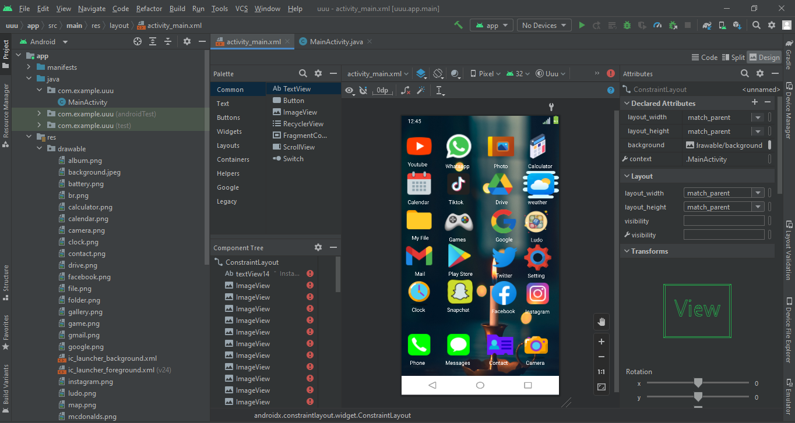

**LINEAR LAYOUT**

<?xml version="1.0" encoding="utf-8"?>

<LinearLayout xmlns:android="http://schemas.android.com/apk/res/android"

xmlns:app="http://schemas.android.com/apk/res-auto"

xmlns:tools="http://schemas.android.com/tools"

android:layout_width="match_parent"

android:layout_height="match_parent"

android:orientation="vertical"

tools:context=".MainActivity"

android:background="@drawable/background">

<LinearLayout

android:layout_width="match_parent"

android:layout_height="wrap_content"

android:layout_marginLeft="20dp"

android:layout_marginRight="20dp"

>

<ImageView

android:layout_width="70dp"

android:layout_height="130dp"

android:src="@drawable/setting"

android:layout_marginLeft="15dp"

/>

<TextView

android:id="@+id/textView"

android:layout_width="wrap_content"

android:layout_height="wrap_content"

android:text=""

android:textColor="@color/black"

android:textSize="50sp"

android:textStyle="bold"

app:layout_constraintBottom_toBottomOf="parent"

app:layout_constraintEnd_toEndOf="parent"

app:layout_constraintStart_toStartOf="parent"

app:layout_constraintTop_toTopOf="parent"

app:layout_constraintVertical_bias="0.382" />

<ImageView

android:layout_width="70dp"

android:layout_height="130dp"

android:src="@drawable/video"

android:layout_marginLeft="20dp"

/>

<ImageView

android:layout_width="70dp"

android:layout_height="130dp"

android:src="@drawable/weather"

android:layout_marginLeft="20dp"

/>

<ImageView

android:layout_width="70dp"

android:layout_height="130dp"

android:src="@drawable/file"

android:layout_marginLeft="20dp"

/>

</LinearLayout>

<LinearLayout

android:layout_width="match_parent"

android:layout_height="wrap_content"

android:layout_marginLeft="20dp"

android:layout_marginRight="20dp"

>

<ImageView

android:layout_width="70dp"

android:layout_height="130dp"

android:src="@drawable/snapchat"

android:layout_marginLeft="15dp"

/>

<ImageView

android:layout_width="70dp"

android:layout_height="130dp"

android:src="@drawable/instagram"

android:layout_marginLeft="20dp"

/>

<ImageView

android:layout_width="70dp"

android:layout_height="130dp"

android:src="@drawable/facebook"

android:layout_marginLeft="20dp"

/>

<ImageView

android:layout_width="70dp"

android:layout_height="130dp"

android:src="@drawable/twitter"

android:layout_marginLeft="20dp"

/>

</LinearLayout>

<LinearLayout

android:layout_width="match_parent"

android:layout_height="wrap_content"

android:layout_marginLeft="20dp"

android:layout_marginRight="20dp"

>

<ImageView

android:layout_width="70dp"

android:layout_height="130dp"

android:src="@drawable/tiktok"

android:layout_marginLeft="15dp"

/>

<ImageView

android:layout_width="70dp"

android:layout_height="130dp"

android:src="@drawable/gmail"

android:layout_marginLeft="20dp"

/>

<ImageView

android:layout_width="70dp"

android:layout_height="130dp"

android:src="@drawable/netflix"

android:layout_marginLeft="20dp"

/>

<ImageView

android:layout_width="70dp"

android:layout_height="130dp"

android:src="@drawable/game"

android:layout_marginLeft="20dp"

/>

</LinearLayout>

<LinearLayout

android:layout_width="match_parent"

android:layout_height="wrap_content"

android:layout_marginLeft="20dp"

android:layout_marginRight="20dp"

>

<ImageView

android:layout_width="70dp"

android:layout_height="130dp"

android:src="@drawable/drive"

android:layout_marginLeft="15dp"

/>

<ImageView

android:layout_width="70dp"

android:layout_height="130dp"

android:src="@drawable/folder"

android:layout_marginLeft="20dp"

/>

<ImageView

android:layout_width="70dp"

android:layout_height="130dp"

android:src="@drawable/file"

android:layout_marginLeft="20dp"

/>

<ImageView

android:layout_width="70dp"

android:layout_height="130dp"

android:src="@drawable/clock"

android:layout_marginLeft="20dp"

/>

</LinearLayout>

<LinearLayout

android:layout_width="match_parent"

android:layout_height="wrap_content"

android:layout_marginLeft="20dp"

android:layout_marginRight="20dp"

android:layout_marginTop="30dp"

>

<ImageView

android:layout_width="70dp"

android:layout_height="130dp"

android:src="@drawable/camera"

android:layout_marginLeft="15dp"

/>

<ImageView

android:layout_width="70dp"

android:layout_height="130dp"

android:src="@drawable/contact"

android:layout_marginLeft="20dp"

/>

<ImageView

android:layout_width="70dp"

android:layout_height="130dp"

android:src="@drawable/phone"

android:layout_marginLeft="20dp"

/>

<ImageView

android:layout_width="70dp"

android:layout_height="130dp"

android:src="@drawable/messages"

android:layout_marginLeft="20dp"

/>

</LinearLayout>

</LinearLayout>

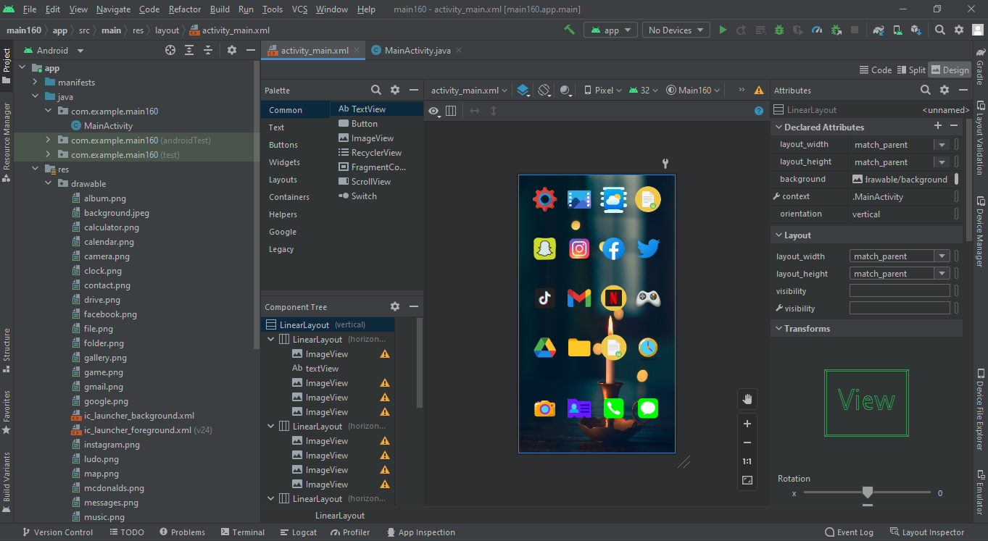

**QUESTION:4**

**(A)**

<?xml version="1.0" encoding="utf-8"?>

<androidx.constraintlayout.widget.ConstraintLayout xmlns:android="http://schemas.android.com/apk/res/android"

xmlns:app="http://schemas.android.com/apk/res-auto"

xmlns:tools="http://schemas.android.com/tools"

android:layout_width="match_parent"

android:layout_height="match_parent"

android:background="@drawable/back4"

tools:context=".MainActivity">

<ImageView

android:layout_width="120dp"

android:layout_height="100dp"

android:background="@drawable/pie2"

tools:layout_editor_absoluteX="42dp"

tools:layout_editor_absoluteY="29dp" />

<ImageView

android:layout_width="100dp"

android:layout_height="100dp"

android:background="@drawable/gift"

tools:layout_editor_absoluteX="18dp"

tools:layout_editor_absoluteY="598dp" />

<ImageView

android:layout_width="100dp"

android:layout_height="100dp"

android:background="@drawable/rocket"

tools:layout_editor_absoluteX="16dp"

tools:layout_editor_absoluteY="482dp" />

<ImageView

android:layout_width="78dp"

android:layout_height="75dp"

android:background="@drawable/shop2"

tools:layout_editor_absoluteX="0dp"

tools:layout_editor_absoluteY="352dp" />

<ImageView

android:layout_width="78dp"

android:layout_height="75dp"

android:background="@drawable/shop"

tools:layout_editor_absoluteX="204dp"

tools:layout_editor_absoluteY="352dp" />

<ImageView

android:layout_width="78dp"

android:layout_height="75dp"

android:background="@drawable/star2"

tools:layout_editor_absoluteX="96dp"

tools:layout_editor_absoluteY="352dp" />

<ImageView

android:layout_width="78dp"

android:layout_height="75dp"

android:background="@drawable/dining"

tools:layout_editor_absoluteX="311dp"

tools:layout_editor_absoluteY="352dp" />

<TextView

android:id="@+id/s1"

android:layout_width="25dp"

android:layout_height="100dp"

android:background="@drawable/shape"

app:layout_constraintBottom_toBottomOf="parent"

app:layout_constraintEnd_toEndOf="parent"

app:layout_constraintHorizontal_bias="0.075"

app:layout_constraintStart_toStartOf="parent"

app:layout_constraintTop_toTopOf="parent"

app:layout_constraintVertical_bias="0.326" />

<TextView

android:id="@+id/s1"

android:layout_width="25dp"

android:layout_height="69dp"

android:background="@drawable/shape2"

app:layout_constraintBottom_toBottomOf="parent"

app:layout_constraintEnd_toEndOf="parent"

app:layout_constraintHorizontal_bias="0.886"

app:layout_constraintStart_toStartOf="parent"

app:layout_constraintTop_toTopOf="parent"

app:layout_constraintVertical_bias="0.358" />

<TextView

android:id="@+id/s1"

android:layout_width="25dp"

android:layout_height="69dp"

android:background="@drawable/shape3"

app:layout_constraintBottom_toBottomOf="parent"

app:layout_constraintEnd_toEndOf="parent"

app:layout_constraintHorizontal_bias="0.746"

app:layout_constraintStart_toStartOf="parent"

app:layout_constraintTop_toTopOf="parent"

app:layout_constraintVertical_bias="0.358" />

<TextView

android:id="@+id/s1"

android:layout_width="25dp"

android:layout_height="45dp"

android:background="@drawable/shape4"

app:layout_constraintBottom_toBottomOf="parent"

app:layout_constraintEnd_toEndOf="parent"

app:layout_constraintHorizontal_bias="0.626"

app:layout_constraintStart_toStartOf="parent"

app:layout_constraintTop_toTopOf="parent"

app:layout_constraintVertical_bias="0.38" />

<TextView

android:id="@+id/s1"

android:layout_width="25dp"

android:layout_height="30dp"

android:background="@drawable/shape5"

app:layout_constraintBottom_toBottomOf="parent"

app:layout_constraintEnd_toEndOf="parent"

app:layout_constraintHorizontal_bias="0.481"

app:layout_constraintStart_toStartOf="parent"

app:layout_constraintTop_toTopOf="parent"

app:layout_constraintVertical_bias="0.393" />

<TextView

android:id="@+id/s1"

android:layout_width="25dp"

android:layout_height="100dp"

android:background="@drawable/shape6"

app:layout_constraintBottom_toBottomOf="parent"

app:layout_constraintEnd_toEndOf="parent"

app:layout_constraintHorizontal_bias="0.321"

app:layout_constraintStart_toStartOf="parent"

app:layout_constraintTop_toTopOf="parent"

app:layout_constraintVertical_bias="0.326" />

<TextView

android:id="@+id/s1"

android:layout_width="25dp"

android:layout_height="50dp"

android:background="@drawable/shape7"

app:layout_constraintBottom_toBottomOf="parent"

app:layout_constraintEnd_toEndOf="parent"

app:layout_constraintHorizontal_bias="0.212"

app:layout_constraintStart_toStartOf="parent"

app:layout_constraintTop_toTopOf="parent"

app:layout_constraintVertical_bias="0.375" />

<TextView

android:id="@+id/textView"

android:layout_width="wrap_content"

android:layout_height="wrap_content"

android:text="MO"

tools:layout_editor_absoluteX="29dp"

tools:layout_editor_absoluteY="306dp" />

<TextView

android:id="@+id/textView2"

android:layout_width="wrap_content"

android:layout_height="wrap_content"

android:text="TU"

tools:layout_editor_absoluteX="82dp"

tools:layout_editor_absoluteY="306dp" />

<TextView

android:id="@+id/textView3"

android:layout_width="wrap_content"

android:layout_height="wrap_content"

android:text="WE"

tools:layout_editor_absoluteX="124dp"

tools:layout_editor_absoluteY="306dp" />

<TextView

android:id="@+id/textView4"

android:layout_width="wrap_content"

android:layout_height="wrap_content"

android:text="TH"

tools:layout_editor_absoluteX="186dp"

tools:layout_editor_absoluteY="306dp" />

<TextView

android:id="@+id/textView5"

android:layout_width="wrap_content"

android:layout_height="wrap_content"

android:text="FR"

tools:layout_editor_absoluteX="242dp"

tools:layout_editor_absoluteY="306dp" />

<TextView

android:id="@+id/textView6"

android:layout_width="wrap_content"

android:layout_height="wrap_content"

android:text="SA"

tools:layout_editor_absoluteX="288dp"

tools:layout_editor_absoluteY="306dp" />

<TextView

android:id="@+id/textView7"

android:layout_width="wrap_content"

android:layout_height="wrap_content"

android:text="SU"

tools:layout_editor_absoluteX="342dp"

tools:layout_editor_absoluteY="306dp" />

<TextView

android:id="@+id/textView8"

android:layout_width="wrap_content"

android:layout_height="wrap_content"

android:text="Store"

android:textColor="@color/black"

tools:layout_editor_absoluteX="29dp"

tools:layout_editor_absoluteY="427dp" />

<TextView

android:id="@+id/textView9"

android:layout_width="wrap_content"

android:layout_height="wrap_content"

android:text="Collection"

android:textColor="@color/black"

tools:layout_editor_absoluteX="100dp"

tools:layout_editor_absoluteY="427dp" />

<TextView

android:id="@+id/textView10"

android:layout_width="wrap_content"

android:layout_height="wrap_content"

android:text="Shopping"

android:textColor="@color/black"

tools:layout_editor_absoluteX="211dp"

tools:layout_editor_absoluteY="427dp" />

<TextView

android:id="@+id/textView11"

android:layout_width="wrap_content"

android:layout_height="wrap_content"

android:text="Cart Dining"

android:textColor="@color/black"

tools:layout_editor_absoluteX="313dp"

tools:layout_editor_absoluteY="427dp" />

<TextView

android:id="@+id/textView12"

android:layout_width="wrap_content"

android:layout_height="wrap_content"

android:text="Network Fee"

android:textColor="@color/black"

android:textSize="25sp"

android:textStyle="bold"

tools:layout_editor_absoluteX="162dp"

tools:layout_editor_absoluteY="482dp" />

<TextView

android:id="@+id/textView13"

android:layout_width="wrap_content"

android:layout_height="wrap_content"

android:text="Welfare"

android:textColor="@color/black"

android:textSize="25sp"

android:textStyle="bold"

tools:layout_editor_absoluteX="162dp"

tools:layout_editor_absoluteY="609dp" />

<TextView

android:id="@+id/textView14"

android:layout_width="wrap_content"

android:layout_height="wrap_content"

android:text="26$"

android:textColor="#04557A"

android:textSize="25sp"

android:textStyle="bold"

tools:layout_editor_absoluteX="356dp"

tools:layout_editor_absoluteY="494dp" />

<TextView

android:id="@+id/textView15"

android:layout_width="wrap_content"

android:layout_height="wrap_content"

android:text="255$"

android:textColor="#084C6A"

android:textSize="25sp"

android:textStyle="bold"

tools:layout_editor_absoluteX="349dp"

tools:layout_editor_absoluteY="609dp" />

<TextView

android:id="@+id/textView16"

android:layout_width="wrap_content"

android:layout_height="wrap_content"

android:text="Used in May"

tools:layout_editor_absoluteX="165dp"

tools:layout_editor_absoluteY="537dp" />

<TextView

android:id="@+id/textView17"

android:layout_width="wrap_content"

android:layout_height="wrap_content"

android:text="Special Recommendation"

tools:layout_editor_absoluteX="165dp"

tools:layout_editor_absoluteY="656dp" />

<TextView

android:id="@+id/textView18"

android:layout_width="wrap_content"

android:layout_height="wrap_content"

android:text="Available Balance"

android:textStyle="bold"

android:textColor="@color/black"

android:textSize="25sp"

tools:layout_editor_absoluteX="211dp"

tools:layout_editor_absoluteY="29dp" />

<TextView

android:id="@+id/textView19"

android:layout_width="wrap_content"

android:layout_height="wrap_content"

android:text="12,126$"

android:textStyle="bold"

android:textColor="#04557A"

android:textSize="25sp"

tools:layout_editor_absoluteX="296dp"

tools:layout_editor_absoluteY="78dp" />

</androidx.constraintlayout.widget.ConstraintLayout>

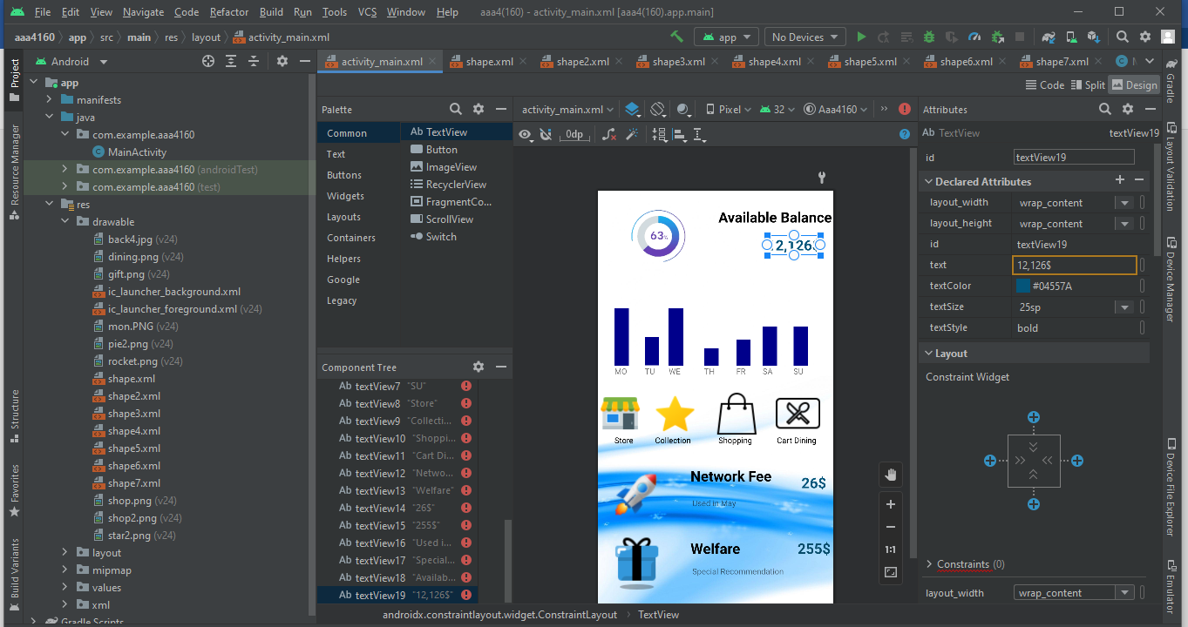

**(B)**

<?xml version="1.0" encoding="utf-8"?>

<androidx.constraintlayout.widget.ConstraintLayout xmlns:android="http://schemas.android.com/apk/res/android"

xmlns:app="http://schemas.android.com/apk/res-auto"

xmlns:tools="http://schemas.android.com/tools"

android:layout_width="match_parent"

android:layout_height="match_parent"

tools:context=".MainActivity">

<Button

android:id="@+id/textView3"

android:layout_width="200dp"

android:layout_height="150dp"

android:background="@color/white"

android:text="6220***789

EXP DATE 12/23"

android:textAlignment="center"

android:textColor="#000000"

android:textSize="25sp"

android:textStyle="normal"

app:backgroundTint="#abd7eb"

app:layout_constraintBottom_toBottomOf="parent"

app:layout_constraintEnd_toEndOf="parent"

app:layout_constraintHorizontal_bias="0.985"

app:layout_constraintStart_toStartOf="parent"

app:layout_constraintTop_toTopOf="parent"

app:layout_constraintVertical_bias="0.161" />

<Button

android:id="@+id/textView3"

android:layout_width="200dp"

android:layout_height="150dp"

android:background="@color/white"

android:text="6220***546

Exp DATE

12/23"

android:textAlignment="center"

android:textColor="#000000"

android:textSize="25sp"

android:textStyle="normal"

app:backgroundTint="#ffb8bf"

app:layout_constraintBottom_toBottomOf="parent"

app:layout_constraintEnd_toEndOf="parent"

app:layout_constraintHorizontal_bias="0.0"

app:layout_constraintStart_toStartOf="parent"

app:layout_constraintTop_toTopOf="parent"

app:layout_constraintVertical_bias="0.161" />

<ImageView

android:id="@+id/imageView2"

android:layout_width="200dp"

android:layout_height="150dp"

android:background="@drawable/pic"

tools:layout_editor_absoluteX="211dp"

tools:layout_editor_absoluteY="252dp" />

<ImageView

android:id="@+id/imageView2"

android:layout_width="300dp"

android:layout_height="100dp"

android:background="@drawable/pic2"

tools:layout_editor_absoluteX="57dp"

tools:layout_editor_absoluteY="635dp" />

<Button

android:id="@+id/textView3"

android:layout_width="200dp"

android:layout_height="150dp"

android:background="@color/white"

android:text="6501**779

Exp date

12/23"

android:textAlignment="Left"

android:textColor="#000000"

android:textSize="25sp"

android:textStyle="normal"

app:backgroundTint="#FFCC99"

app:layout_constraintBottom_toBottomOf="parent"

app:layout_constraintEnd_toEndOf="parent"

app:layout_constraintHorizontal_bias="0.0"

app:layout_constraintStart_toStartOf="parent"

app:layout_constraintTop_toTopOf="parent"

app:layout_constraintVertical_bias="0.433" />

<TextView

android:id="@+id/textView"

android:layout_width="150dp"

android:layout_height="80dp"

android:text="CARDS"

android:textColor="#000000"

android:textSize="45sp"

android:textStyle="bold"

app:layout_constraintEnd_toEndOf="parent"

app:layout_constraintHorizontal_bias="0.068"

app:layout_constraintStart_toStartOf="parent"

tools:layout_editor_absoluteY="26dp" />

<TextView

android:id="@+id/textView2"

android:layout_width="wrap_content"

android:layout_height="wrap_content"

android:text="LOANS"

android:textColor="#000000"

android:textSize="45sp"

android:textStyle="bold"

tools:layout_editor_absoluteX="16dp"

tools:layout_editor_absoluteY="411dp" />

<TextView

android:id="@+id/s1"

android:layout_width="match_parent"

android:layout_height="150dp"

android:layout_marginStart="8dp"

android:layout_marginLeft="8dp"

android:background="@drawable/shape"

android:textSize="20dp"

app:layout_constraintBottom_toBottomOf="parent"

app:layout_constraintStart_toStartOf="parent"

app:layout_constraintTop_toTopOf="parent"

app:layout_constraintVertical_bias="0.81" />

<ImageView

android:id="@+id/imageView2"

android:layout_width="150dp"

android:layout_height="150dp"

android:background="@drawable/pic3"

tools:layout_editor_absoluteX="258dp"

tools:layout_editor_absoluteY="471dp" />

<TextView

android:id="@+id/textView4"

android:layout_width="wrap_content"

android:layout_height="wrap_content"

android:text="student loan"

android:textSize="20sp"

tools:layout_editor_absoluteX="57dp"

tools:layout_editor_absoluteY="492dp" />

<TextView

android:id="@+id/textView5"

android:layout_width="wrap_content"

android:layout_height="wrap_content"

android:text="12,1265$"

android:textColor="#000000"

android:textSize="30sp"

tools:layout_editor_absoluteX="57dp"

tools:layout_editor_absoluteY="519dp" />

<TextView

android:id="@+id/textView6"

android:layout_width="wrap_content"

android:layout_height="wrap_content"

android:text="student loan"

android:textSize="20sp"

tools:layout_editor_absoluteX="69dp"

tools:layout_editor_absoluteY="559dp" />

<TextView

android:id="@+id/textView7"

android:layout_width="wrap_content"

android:layout_height="wrap_content"

android:text="Amount 2,160$"

android:textColor="#000000"

android:textSize="30sp"

tools:layout_editor_absoluteX="28dp"

tools:layout_editor_absoluteY="586dp" />

</androidx.constraintlayout.widget.ConstraintLayout>

